Software Requirements Specification

for

CUSTOMER CARE DATABASE

Version 2.0 approved

Prepared by <S10_2>

<Banking>

1 October 2020

# Introduction

## Purpose

The primary purpose of this document is to provide support information and an overview regarding the Customer Database Project for Financial Institutions. It attempts to explain the primary functionality and features of the aforementioned product from a broad perspective.

## Intended Audience and Reading Suggestions

While the software requirement specification (SRS) document is written for a more general audience, this document is intended for:

* Developers who can review project’s capabilities and more easily understand where their efforts should be targeted to improve or add more features to it (design and code the application – it sets the guidelines for future development).
* Project testers can use this document as a base for their testing strategy as some bugs are easier to find using a requirements document. This way testing becomes more methodically organized.
* Developers and Testers are encouraged to have a pre-requisite knowledge regarding Database Design and SQL functionalities/queries.
* End users of this application who wish to read about what this project can do.

This document need not be read sequentially. Users are encouraged to jump to any section they find relevant.

## Product Scope

The primary purpose of this Customer Care Database is to meet the expectations of the customers with regards to an array of services/queries spanning over a wide variety of Financial Institutions. In addition to that it also aims to provide customers with constructive solutions for a user-friendly and hassle-free experience for their desired query/service. This product also aims to understand the queries of the customers and ensure that they enjoy a cost-effective and flawless experience with respect to their service. It furthermore enables the Service Providers to gain better insights with regards to the usability of their products which in turn helps them improve their services/products and makes them more efficient.

# Overall Description

## Product Perspective

Users can get information regarding their account/balance after validating their account and can furthermore transfer money to other valid accounts. In addition to that customers can also block their existing accounts in case of extraordinary events. Other general queries within the purview of the system shall also be catered to. Administrators would have access to the entire database in order to maintain information integrity throughout the database. Service Providers would have a lower sense of privilege with regards to the Admin and can only modify/provide information when prompted by the user.

**[B] 1. Background Readings**

**Description:**

* **Book**:

Database System Concepts by Abraham Silberschatz: We read part 1-Relational languages, and part 2- Database design from the book. We learned now the relational model remains the primary data model for commercial data-processing applications. It attained its primary position because of its simplicity, which eases the job of the programmer, compared to earlier data models such as the network model or the hierarchical model. We also learned about important concepts, logic and different terminologies that will be useful while working on this project. Continuing the reading we were introduced to database design using ER model and how can it be transformed into a set of relation schemas and how some of the constraints can be captured in this design. The various features of the E-R model offer the database designer numerous choices in how to best represent the enterprise being modelled. Concepts and objects may, in certain cases, be represented by entities, relationships, or attributes. Aspects of the overall structure of the enterprise may be best described by using weak entity sets, generalization, specialization, or aggregation. Often, the designer must weigh the merits of a simple, compact model versus those of a more precise, but more complex one. UML is a popular modelling language. UML class diagrams are widely used for modelling classes, as well as for general-purpose data modelling.

* **Websites**:

We read numerous blogs and articles on individual database concepts but more importantly we had to understand what kinds of customer care services do most banks offer so that we could decide what features we wanted to include and also helped us the existing problems and possible solutions and how can we implement them. In order to properly understand customer care solutions, we looked up for various companies and start-ups providing such services and how they are trying to optimize and utilizing the queries to improve their services.

* **Videos:**

PostgreSQL Tutorial For Beginners | Learn PostgreSQL | Introduction to PostgreSQL | Edureka: Since we will be working on PostgreSQL, we had to take a basic course to strengthen our fundamentals. It covered all beginner topics from commands, keys, entity, constraints, operators, triggers and functions.

How to Design Your First Database: This video covered the rules to follow when designing databases, as well as general design principles.

**References:**

* <https://www.geeksforgeeks.org/how-to-write-a-good-srs-for-your-project/>
* <https://medium.com/@vincetran_28429/software-requirements-specification-srs-document-fd9ab103b18>
* <https://www.geeksforgeeks.org/introduction-of-er-model/>
* <https://www.tutorialspoint.com/dbms/er_model_to_relational_model.htm>
* <https://nptel.ac.in/courses/106/106/106106093/>
* <https://www.creditmantri.com/customer-care/>
* <https://www.slideshare.net/AshwinkumarDinoriya/banking-database>
* <https://www.youtube.com/watch?v=-VO7YjQeG6Y>
* <https://www.youtube.com/playlist?list=PLQVJk9oC5JKohoyVILfdxOOzyl6w-yOur>

**Combined requirements:**

* Problem analysis
* Determine the purpose of the database
* Determining data to be stored
* Find and organize the information required
* Determining data relationships
* Logically structuring data
* ER diagram
* Divide the information into tables
* Physical Schema Design
* Specify constraints
* Set up the table relationships
* Apply the normalization rules

**2) INTERVIEW PLAN:**

Designation of the Interviewer: Backend Developer for Customer Care Database

Place: Zoom meetings

Date: 27th September 2020

People Interviewed:

|  |  |  |  |  |
| --- | --- | --- | --- | --- |
| Name | Purpose/Agenda | Duration | Designation | Time |
| Harish Tyagi (22) | To understand how existing services can be improved. | 30 mins | Software Developer | 10:30 AM |
| Durgadas Banerjee (62) | To ascertain how frequently elderly people, use customer care services and their requirements. | 28 mins | Retired Army Personnel | 11:00 AM |
| Alpesh Sharma (49) | To understand the time constraints of middle age/working people | 35 mins | Businessman | 12:00 PM |
| Abhishek Mehra (35) | To understand how existing services can be improved. | 40 mins | Stock Broker | 12:45 PM |

**Combined Requirements:**

* Prioritizing issues for middle-aged and elderly people as they primarily face a lot of time constraints as opposed to the younger generation.
* Issues which demand immediate attention (Blocking or suspending accounts) should be prioritized irrespective of the age group.
* Recurring Issues should be solved more efficiently at later stages.

**3)Questionnaire:**

Question 1

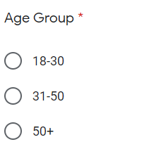

Question 2)

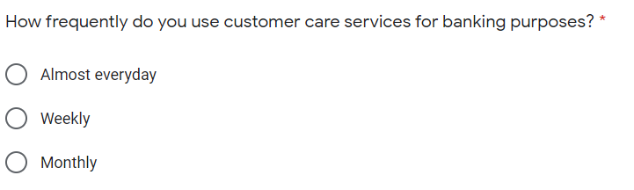

Question 3)

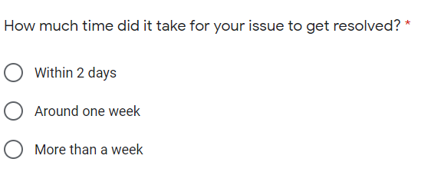

Question 4)

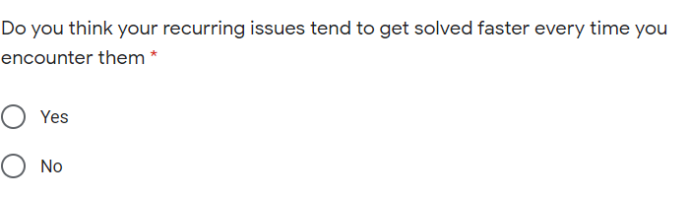

Question 5)

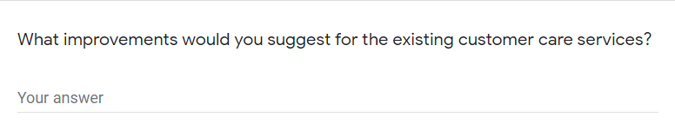

**4) OBSERVATIONS:**

* The first graph represents the age distribution of the people who filled up the survey form. This demography distribution shall help us to understand the rest of the survey responses better and furthermore help in generating a constructive feedback loop to understand the existing flaws and implement thee required functionalities.

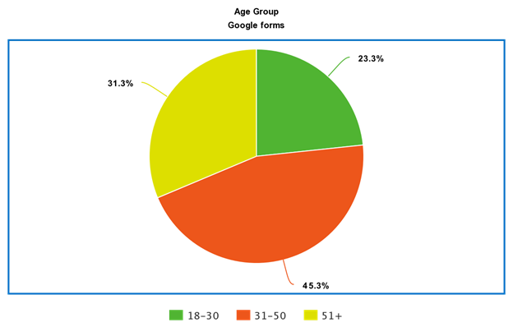

* The second graph represents the response to Q2 present in the form. The following observations have been made:
  1. Most of the people in the age bracket of 18-30 years, tend to require these services almost every day. This can be explained by that fact that most of these people tend to have a lot of bank transactions via digital forms. Hence its essential that they stay updated to avoid faulty/erroneous transactions
  2. We observe that people in the age range of 31-50 years primarily use these services on a weekly basis. This can be attributed to the fact that they are working professionals and can’t devote time for such issues on a daily basis. Time is an important factor for this class of people.
  3. 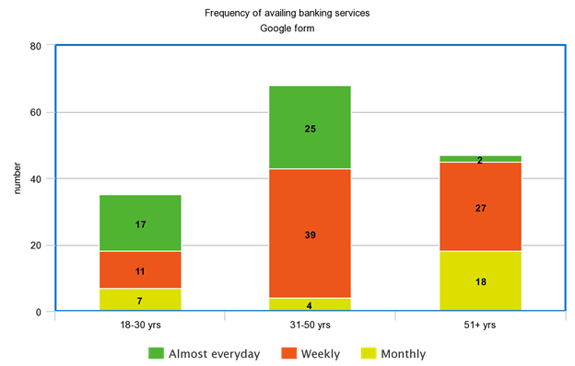For elderly people, most of them have contact the customer care in a weekly or monthly. Since they are not involved in frequent transactions, hence their interaction on a daily basis with customer care services is quite diminished.
* This graph primarily represents the time required to solve issues pertaining to the banking services offered:
  1. For the younger audience most of their queries were solved within a day or two. This is primarily due to the fact that most of their issues are less complex in nature and hence can be done faster.
  2. For the middle aged there is an equitable distribution in all 3 categories. This is because their issues span over a wide range of services. Still there remains a considerable number of issues which take up a large amount of time (around a week). This is worrisome especially since they have a time constraint imposed upon them.
  3. 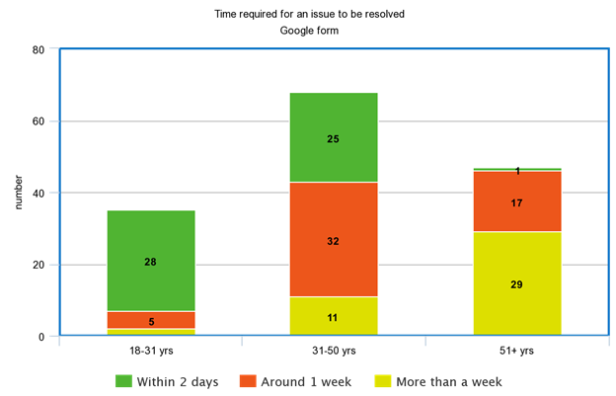For the elderly, majority of their issues take a large amount of time to get solved. The complexity of their issues may have a role to play in this scenario.
* 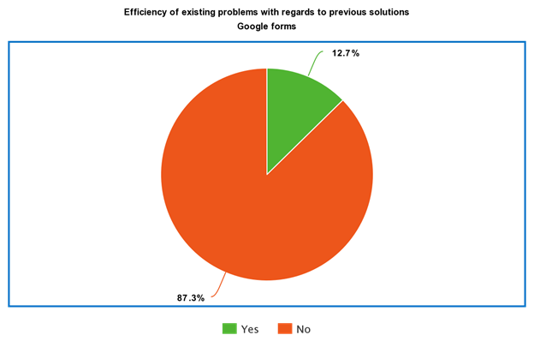About 87.3% of the people seem to think that the existing service does not seem to get more efficient when they have an issue which they had also previously faced. This is a major point to work upon as it affects all the age groups.

**C) FACT FINDING CHART:**

|  |  |  |  |
| --- | --- | --- | --- |
| **Objective** | **Technique** | **Subject(s)** | **Time Commitment** |
| To know, how often do people need banking services | Interview | One elderly person,  a middle aged person | 2x1 hour each |
| To know how long does it take for one’s complaint to get registered and get resolved | Interview, Survey | Google forms, a few middle aged people | 1 day for google form, Number of people x ½ hour each |
| To know that if any complaint lodged is along the previous lines, how long does it take to get resolved. | Survey | Google forms | 1 day |
| To know how can the existing banking services could be improved | Interview | People from all the age group | 2 days |
| The study of schema of bank databases and how are customers catered | Background reading | Online websites, journals | 1 day |
| To find how people prefer the banking services, i.e. online or offline. | Interview and survey | Google forms, people from all the age group | 1 day |

**D) LIST REQUIREMENTS: -**

* A major requirement especially among elderly and middle-aged people was with regards to efficiency. Recurring Issues which have been already solved in the past should typically be solved faster and shouldn’t take the same amount of time as that of the previous ones.
* Issues pertaining to middle-aged and elder people should typically be prioritized in cases where a significant time is already being invested in solving the issue. This is primarily to facilitate the time crunch faced by middle-aged people and to accommodate the elderly as well.
* The System must have provisions to accommodate cancelling cards/accounts in extreme situations on an urgent priority basis irrespective of the age group.

**E) USER CLASSES AND CHARACTERISTICS: -**

There are basically three categories of users: -

* Administrator: These people are involved in managing the database
* Service Provider: These are responsible for providing services to the customers by accessing the relevant data from the database.
* End user: These are the people who avail the services.

**F) OPERATING ENVIRONMENT:**

**Recommended Operating Systems: -**

* **Windows:** 7 or newer
* **MAC:** OS X v10.7 or higher
* **Linux:** Ubuntu

**Hardware Requirements: -**

* We strongly recommend a computer fewer than 5 years old.
* Processor: Minimum 1 GHz; Recommended 2GHz or more.
* Hard Drive: Minimum 32 GB; Recommended 64 GB or more.
* Memory (RAM): Minimum 1 GB; Recommended 4 GB or above.
* Some classes require a camera and microphone.

**Recommended Operating Browsers: -**

* Safari version 7 and above.
* Chrome version 44 and above.
* Firefox version 40 and above.

**G) PRODUCT FUNCTIONS:**

This section provides the functional overview of the customer care database. Various functional modules that can be accessed by the user are:

1. **Login:**

This module allows valid customers to access the functionalities provided by the bank. Customer logins by entering customer id and the login pin.

1. **Get balance information:**

This module maintains the balance details of a particular account. This system must be networked to the bank’s computer. The updated database of every customer is maintained with bank. Hence the balance information of every account is available in the database and can be displayed to the customer.

1. **Customer info:**

This module allows the customer to view and update the profile of their account. It also allows them to view their account status, load information and transaction details.

**4. Transfer Money:**

This module allows the customers to transfer funds from one account to another within the same bank.

**5. General Grievances:**

This module allows the customer to suspend their account and block their cards.

**H) PRIVILEGES:**

* **Administrator:** His role includes capacity planning, installation configuration, database design, data recovery etc. These are exclusive tasks and are only to be performed by the administrator. No one else except the admin has the access to person these tasks.
* **Service Provider:** The service provider primarily has access to look into the database. This allows them to help the customers with resolving their queries and providing them with services. Also, the service provider can modify certain fields of the database to cater to the immediate needs of the user provided he/she has provided the login credentials.
* **End User:** They will not be having any access, i.e. they cannot modify or look up the entire database. They can just avail the services and will only be allowed to look into their own data, i.e. their account number, bank balance, etc.

**I) ASSUMPTIONS:**

* We have assumed that the customer care services possess the complete data regarding the customer’s bank accounts and are not dependent on the banks to explicitly provide that information.
* We have also assumed that the service providers/admin can block any account or any debit/credit card if the customer wishes so. There is no need for a confirmation from the bank regarding this issue.
* The bank has given explicit authority to the customer care center to read and modify the information of the customers.

**J) BUSINESS CONSTRAINTS:**

* Scalability of the aforementioned database could be an issue if the user pool is extremely large. Distributed Database Systems need to be used for that.
* The data needs to be stored on a server. For large amounts of data, storing it on cloud servers could be an expensive affair.
* For highly scaled systems, there should be dedicated personnel to maintain and handle the complete system.